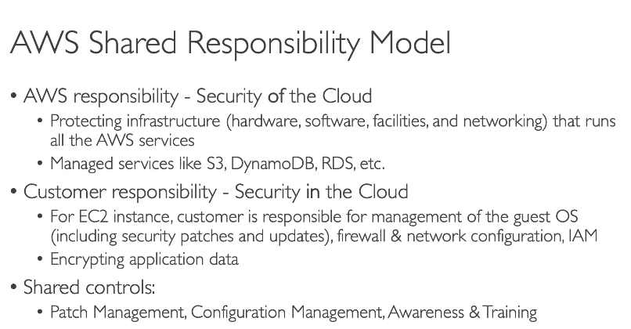
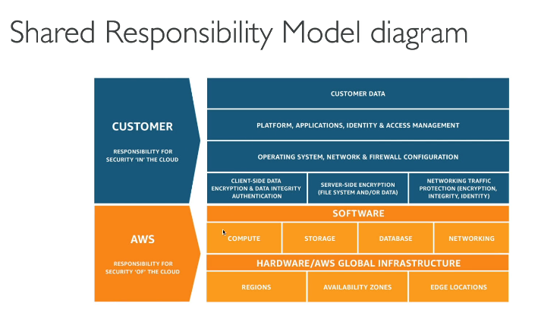
What is the Shared Responsibility Model?
It’s a security and compliance framework where:
- AWS is responsible for the security of the cloud
- You (the customer) are responsible for security in the cloud
This means AWS handles the infrastructure, while you handle your own usage of AWS services.

🎯 Real-World Analogy: Renting an Apartment
- 🏢 Landlord (AWS): Provides the building, locks, security cameras, plumbing, electricity.
- 🧍‍♂️ Tenant (You): Responsible for locking your door, not leaving the stove on, and choosing who comes in.
Similarly:
- AWS secures the data centers, hardware, network.
- You manage your data, access, encryption, and configuration.
🔐 Breakdown of Responsibilities
Area | AWS (Security of the Cloud) |  |  |  | You (Security in the Cloud)
Physical Security | ✅ |  |  |  | ❌
Networking | ✅ |  |  |  | ❌
Hardware (Compute, Storage) | ✅ |  |  |  | ❌
Virtualization Layer | ✅ |  |  |  | ❌
Operating System (EC2) | ❌ |  |  |  | ✅
Application Code | ❌ |  |  |  | ✅
Data & Encryption | ❌ |  |  |  | ✅
Identity & Access (IAM) | ❌ |  |  |  | ✅
Security Groups / VPC settings | ❌ |  |  |  | ✅

🔍 Example Scenarios
📦 S3 Bucket
- AWS: Ensures S3 service is highly available, durable, secure infrastructure.
- You: Must set correct bucket policies, enable encryption, block public access if needed.
🖥️ EC2 Instance
- AWS: Provides secure infrastructure and hypervisor.
- You: Patch the OS, use security groups, install antivirus, configure IAM roles.
📚 RDS Database
- AWS: Manages backup, replication, and OS-level security.
- You: Configure database access, manage users, and encrypt data if needed.
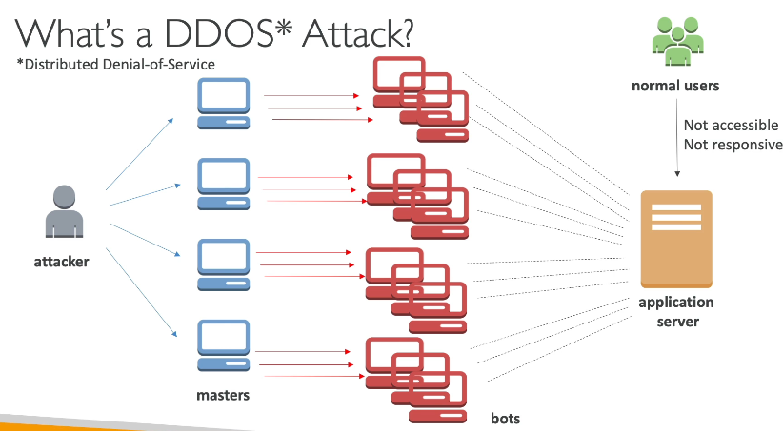
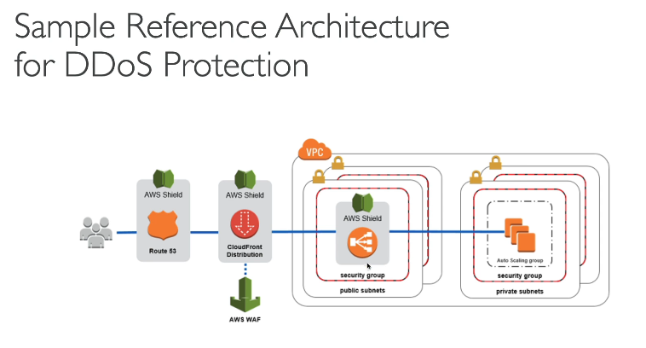
What is DDoS?
DDoS (Distributed Denial of Service) is a cyber attack where attackers flood your website or app with a massive amount of traffic, causing it to slow down or crash — just like a traffic jam on a highway 🚗🚗🚗🚗🚗.

🛡️ How does AWS protect you from DDoS?
AWS provides two main services for DDoS and web protection:

1. 🛡️ AWS Shield
Feature |  |  |  | AWS Shield Standard |  |  |  | AWS Shield Advanced
Cost |  |  |  | ✅ Free |  |  |  | 💰 Paid
Protection |  |  |  | ✅ Against most common DDoS attacks |  |  |  | ✅ Advanced protection (large-scale, targeted attacks)
Use Case |  |  |  | Default for all AWS customers |  |  |  | For critical, high-value apps
Extras (Advanced only) |  |  |  | - 24/7 DDoS Response Team (DRT)
- Attack cost protection
- Real-time alerts |
🧠 Think of Shield Standard as the free security guard at the AWS entrance, and Shield Advanced as a special security team with direct phone support.

2. 🔒 AWS WAF (Web Application Firewall)
WAF protects your web applications from malicious HTTP requests like:
- SQL injection
- Cross-site scripting (XSS)
- Bad bots
- IP blocking
💡 Key Features:
- You can define rules: Block or allow traffic based on IPs, headers, URI, query strings.
- Works with CloudFront, ALB, API Gateway, etc.

🧪 Real-World Scenario:
🎯 Use Case: You have an E-commerce Website
- Suddenly, a flood of fake users start sending traffic to overload your site.
✅ AWS Shield Standard:
- Automatically detects the DDoS attack and starts mitigating it without you doing anything.
✅ AWS WAF:
- You already have a rule to block IPs from certain countries or limit request rate (rate limiting), so many of those malicious requests are blocked before reaching your app.
✅ AWS Shield Advanced (if subscribed):
- You get a real-time alert.
- You call the DDoS Response Team who helps you in live mitigation.
- AWS refunds charges from scaling that happened because of the attack (cost protection).

🧠 TLDR
Service | What It Does | Cost | Best For
AWS Shield Standard | Auto-protection against common DDoS | Free | Everyone
AWS Shield Advanced | Full DDoS protection, support, refund | Paid | Critical apps
AWS WAF | Custom rules to protect apps from web exploits | Paid | Filtering traffic at application level

What is Penetration Testing on AWS?
Penetration testing is the authorized simulation of cyberattacks on your AWS resources to identify vulnerabilities and improve your security posture.

✅ Services That You Can Pen Test Without Prior Approval
As of AWS's current policy (which can change), you can perform pen tests without prior approval on:
Service | Examples
EC2 Instances | Testing your own virtual machines
RDS | Attacking your own DB endpoint (no DDoS)
CloudFront | Only if you control the distribution
API Gateway | Testing your own APIs
Lambda Functions | Testing event triggers, input handling
Lightsail | Similar to EC2
Elastic Beanstalk | Applications deployed via EB
Aurora | Same rules as RDS
🔸 Important: You must own and control the resources you're testing.

❌ What You CANNOT Do
- No Denial of Service (DoS/DDoS) simulations
- No Port flooding or stress testing
- No DNS zone walking
- No testing services you don’t own (e.g., shared S3 buckets, third-party AMIs)

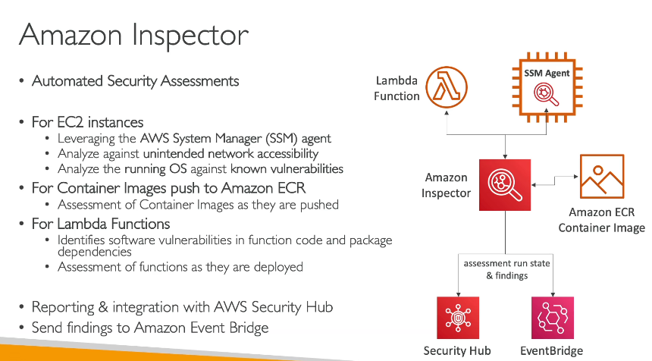
Amazon Inspector – Overview
Amazon Inspector is an automated security assessment service from AWS that helps you improve the security and compliance of your workloads by scanning for vulnerabilities and deviations from best practices.
It is especially useful for:
- EC2 instances
- Lambda functions
- Amazon ECR container images

🚀 Key Features of Amazon Inspector
Feature | Description
Automated Scans | Continuously scans EC2, Lambda, ECR images
CVE Detection | Identifies known vulnerabilities (CVEs) in OS & applications
Risk Scoring | Uses CVSS to assign severity levels
Event-driven | Automatically scans when new resources are launched or pushed
Integration | Works with AWS Organizations, Security Hub, EventBridge

🔍 What Does It Scan?
- EC2 instances
  - OS vulnerabilities (based on CVE)
  - Network exposure
- Lambda functions
  - Application dependencies (e.g., in Python, Node.js)
- Amazon ECR
  - Container images for known vulnerabilities

🛠️ How Amazon Inspector Works (High-level)
- Enable Amazon Inspector
- It automatically integrates with:
  - EC2
  - Lambda
  - ECR
- Scans start automatically based on events:
  - New EC2 instance launch
  - Lambda function deployment
  - New container image pushed to ECR
- Results sent to:
  - Amazon Inspector Console
  - Amazon EventBridge
  - AWS Security Hub (optional)

🧪 Sample Use Case
🎯 Scenario:
You're running a web application on EC2 and pushing containerized microservices to ECR. You want to ensure there are no vulnerabilities in your software stack.
✅ Steps:
- Enable Inspector in the Console
  - Go to Amazon Inspector > Enable
  - Choose EC2, Lambda, and ECR resources
- Launch a new EC2 instance or push a container image
  - Inspector will automatically scan the new instance/image
- View Findings
  - Go to Inspector Dashboard
  - Check severity (Low, Medium, High, Critical)
  - Click to view detailed CVE info and remediation suggestions
- Remediate
  - Apply patches or update the vulnerable libraries
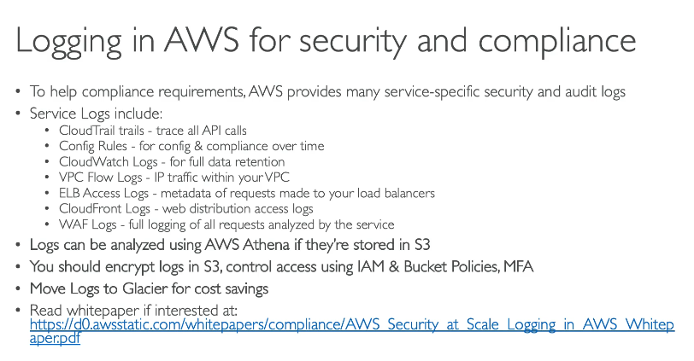

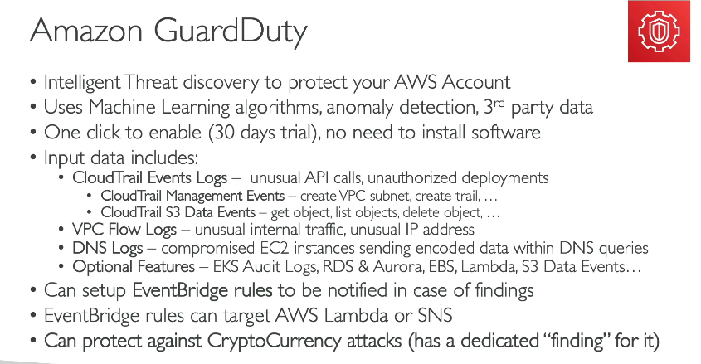
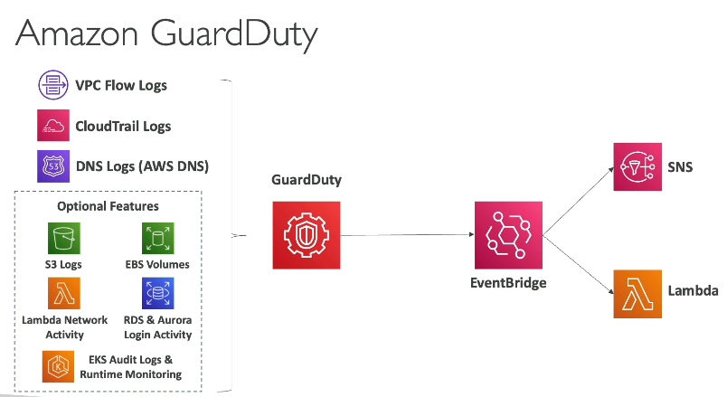
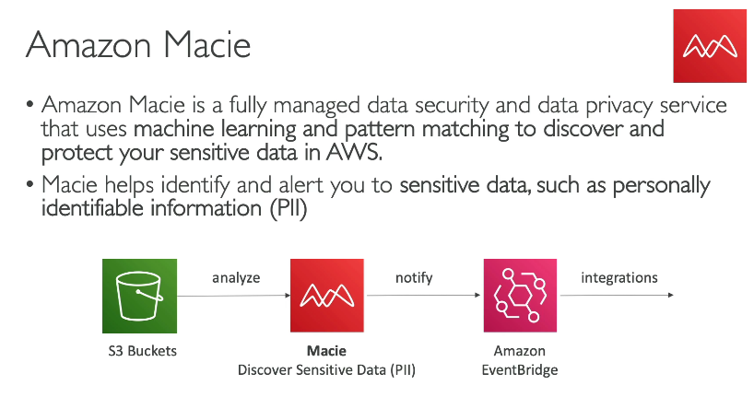
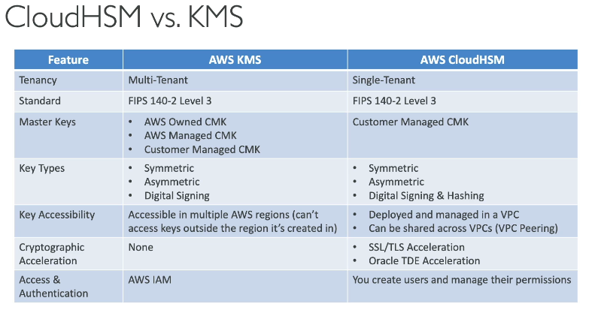
AWS CloudHSM – Overview
AWS CloudHSM is a cloud-based Hardware Security Module (HSM) service that allows you to generate, manage, and use your encryption keys in FIPS 140-2 Level 3 validated hardware.
It gives you full control over your encryption keys, while using AWS to manage the hardware, availability, and scalability.

How It Works (Simplified Steps)
- Create a CloudHSM cluster via the AWS Console
- Launch an HSM in the cluster (in a VPC)
- Initialize the HSM using the client software
- Add users to manage and use keys
- Use PKCS#11, JCE, or CNG libraries to integrate with your apps
- Applications connect to the HSM over the network using a secure channel

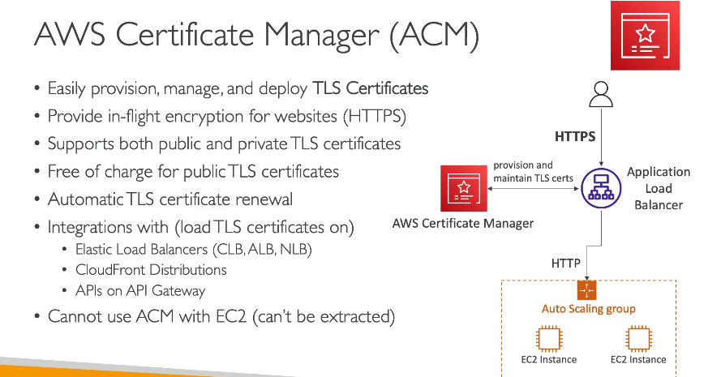
AWS Certificate Manager (ACM) – Overview
AWS Certificate Manager (ACM) is a service that provisions, manages, and deploys SSL/TLS certificates for use with AWS services like CloudFront, Elastic Load Balancing, API Gateway, and more – making it easy to secure your websites and applications.

🧠 Key Features
Feature | Description
Free Public SSL/TLS Certificates | For domains validated via ACM
Automatic Renewal | ACM auto-renews certs issued by ACM
Managed Deployment | Integrates with services like ALB, NLB, CloudFront
Private CA Integration | Manage internal certificates using ACM Private CA
Secure Key Storage | Private keys are securely stored in AWS-managed HSMs

🔑 Types of Certificates
Type | Description
Public Certificates | Issued by Amazon for external domains (e.g., example.com)
Private Certificates | Issued using ACM Private CA for internal use (e.g., int.example.com)

🧾 Validation Methods
Method | Description
DNS Validation | Add a CNAME record in your DNS; preferred for automation
Email Validation | Verify domain ownership via approval email (less common now)
🛠️ Use Case Example
✅ Scenario:
You’ve deployed a React app using CloudFront and S3. You want to secure it using HTTPS.
📌 Steps:
- Go to ACM Console
- Request a certificate
  - Domain: www.example.com
  - Choose DNS validation
- Add the DNS record to your domain’s DNS provider (e.g., Route 53)
- Once validated, the certificate is Issued
- Attach the certificate to:
  - CloudFront Distribution → Use HTTPS-only
  - Or Elastic Load Balancer if using ALB
🔄 Automatic Renewal
- ACM automatically renews public certificates
- You must ensure the domain’s DNS validation record remains intact
- ACM automatically updates the certificate on supported AWS services (no downtime)

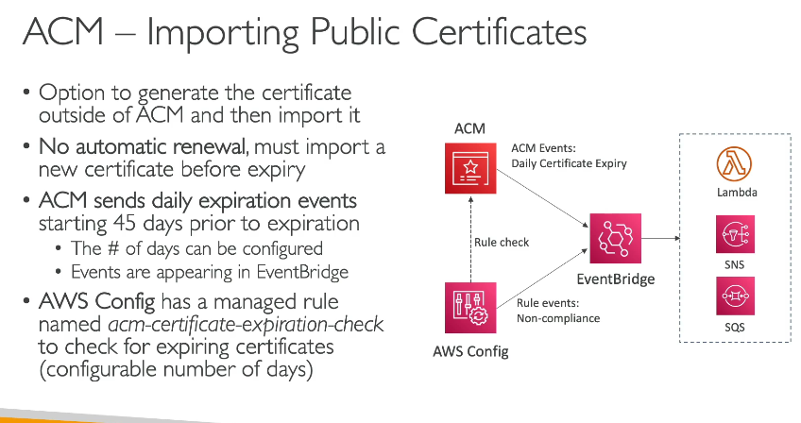
AWS Secrets Manager – Overview
AWS Secrets Manager is a fully managed service that helps you securely store, manage, and retrieve secrets such as:
- Database credentials
- API keys
- Tokens
- SSH keys
- Other sensitive configuration information

🧠 Why Use Secrets Manager?
Feature |  |  |  |  |  |  |  |  | Benefit
🔒 Secure Storage |  |  |  |  |  |  |  |  | Secrets are encrypted at rest using AWS KMS
🔄 Auto-Rotation |  |  |  |  |  |  |  |  | Rotate secrets without downtime
📜 Fine-Grained Access |  |  |  |  |  |  |  |  | Use IAM to control who can access what
📈 Monitoring |  |  |  |  |  |  |  |  | Integrates with CloudWatch Logs and AWS CloudTrail
🔁 Versioning |  |  |  |  |  |  |  |  | Maintains multiple versions of a secret
⚙️ Automation |  |  |  |  |  |  |  |  | Rotate secrets with Lambda or built-in integrations

📘 How It Works – Example Scenario
✅ Scenario:
You have an RDS MySQL database, and you don’t want to hardcode the DB password in your application.

🪜 Steps to Use Secrets Manager:
- Go to Secrets Manager Console
- Click “Store a new secret”
- Choose RDS database credentials
  - Provide username and password
- Select the RDS database from the list
- Set a Secret name (e.g., prod/mysql/db1)
- Optionally configure automatic rotation
- Review and create

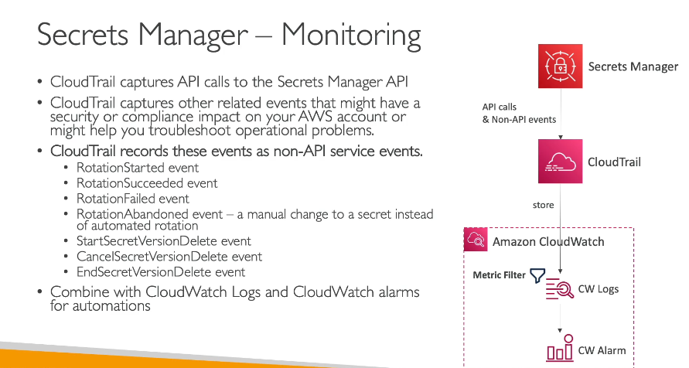
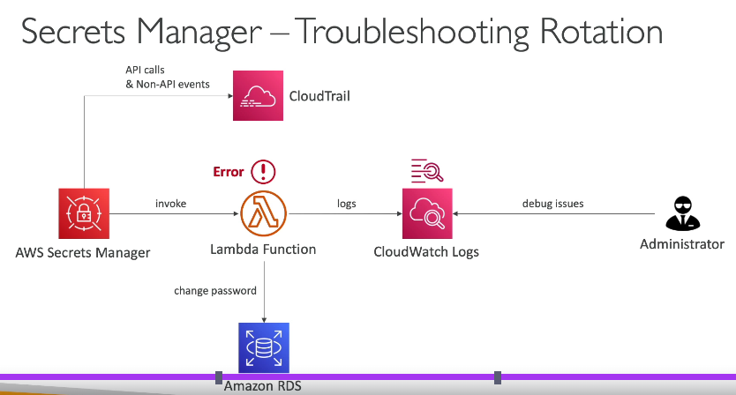

SSM Parameter Store vs Secrets Manager – Comparison Table
Feature / Capability | SSM Parameter Store | AWS Secrets Manager
🔐 Purpose | Store config data, parameters, secrets | Store and rotate sensitive secrets (e.g., DB credentials, API keys)
🏷️ Types of Parameters | - String  - StringList  - SecureString | Secrets (key-value pairs, encrypted by default)
🔑 Encryption | KMS (for SecureString) | Always encrypted with KMS
🔄 Automatic Rotation | ❌ Not natively supported | ✅ Built-in automatic rotation with Lambda
📈 Integration with AWS Services | ✅ (EC2, Lambda, CodePipeline, etc.) | ✅ (RDS, Lambda, ECS, etc.)
👁️‍🗨️ Secret Versioning | Manual versioning via naming/version strategy | ✅ Built-in versioning with metadata
📜 Audit via CloudTrail | ✅ (for API calls) | ✅ (more detailed auditing for secret access)
🔐 Fine-Grained IAM Access | ✅ | ✅
💸 Pricing | - Free (Standard)  - Charged for Advanced tier | Charged per secret + per 10,000 API calls
📦 Size Limit | 4 KB per parameter (Standard); up to 8 KB (Advanced) | 64 KB per secret
🚀 Use Cases | - App config  - Feature flags  - Non-critical secrets | - DB creds  - API tokens  - Highly sensitive secrets

AWS Trusted Advisor correctly because it actively analyzes your AWS account and provides actionable recommendations to optimize cost, improve performance, enhance security, increase fault tolerance, and manage service limits, directly aligning with the learning goal of understanding AWS optimization tools. Great job recognizing the service that helps maintain a well-architected and efficient AWS environment!

"Security Group Rules" correctly because, in the AWS Shared Responsibility Model for RDS, you are responsible for managing network access controls like security group rules, which protect your databases by controlling inbound and outbound traffic. This understanding helps you grasp how cloud providers and users share responsibilities to keep services secure.

AWS GuardDuty correctly because it continuously monitors your AWS environment for suspicious activity, such as exposed credentials, helping you quickly detect and respond to potential security threats; this aligns perfectly with protecting your account from misuse. Keep up the great work in identifying tools that enhance your cloud security!

To support an ongoing audit and prove that AWS has achieved specific compliance certifications, you can use the AWS Artifact service.

✅ What is AWS Artifact?
AWS Artifact is a self-service portal that provides on-demand access to:
- AWS compliance reports
- Security and compliance documents, such as SOC reports, ISO certifications, PCI compliance, and more
What You Can Prove with AWS Artifact Reports:
That AWS data centers and services follow recognized standards
That AWS has undergone third-party audits
That AWS maintains security and privacy controls aligned with compliance frameworks

